# Support auto complete dropdown

# Functional Design

Author: Baotong Wang

Date: January 20, 2014

Contents

Support auto complete dropdown 1

Functional Design 1

Summary 1

User Interface 1

The textbox 1

The dropdown button 2

The dropdown pane 2

Keyboard Interaction 2

Known Issues/Bugs: 3

## Summary

New auto complete dropdown enables users to quickly find and select from a pre-populated list of values as they type, leveraging searching and filtering. By giving an Autocomplete field focus or entering something into it, auto complete starts searching for entries that match and displays a list of values to choose from. By entering more characters, the user can filter down the list to better matches.

It also have the same dropdown icon to allow people do full list select.

## User Interface

New auto complete dropdown will looks like this:

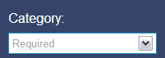

There is a normal input text element and a dropdown icon.

### The textbox

People can input key word into the textbox to finding/filtering target item, when the first character is input auto complete start the searching/filtering, if user delete all characters during the input the whole data will be loaded in the dropdown panel.

### The dropdown button

Click arrow button will open/close the dropdown pane with whole data, keyword is not work when open dropdown by clicking arrow button.

### The dropdown pane

The dropdown pane looks like this:

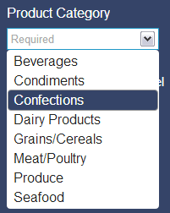

The focus item will be highlighted in the theme color, max-height is 200px and max-width is the textbox width.

### Keyboard Interaction

Auto complete dropdown support below keyboard actions.

When the menu is open, the following key commands are available:

* UP - Move focus to the previous item. If on first item, move focus to the input. If on the input, move focus to last item.
* DOWN - Move focus to the next item. If on last item, move focus to the input. If on the input, move focus to the first item.
* ESCAPE - Close the menu.
* ENTER - Select the currently focused item and close the menu.
* TAB - Select the currently focused item, close the menu, and move focus to the next focusable element.
* PAGE UP/DOWN - Scroll through a page of items (based on height of menu). It's generally a bad idea to display so many items that users need to page..

When the menu is closed, the following key commands are available:

* UP/DOWN - Open the menu.

## Known Issues/Bugs:

1. Enter event conflict, when press enter on a dropdown item a blank page showing.
2. Keyboard interactions are missing when open dropdown by click arrow button.